Capacity in shelters is maxed out as D.C. weakens homeless budget
By Kordell Martin

In her proposed budget, D.C. Mayor Muriel Bowser proposed funding toward renovating emergency and temporary homeless shelters, while longer-term housing options received funding hits. The proposal comes as shelters across the District grapple with high demand, with the population of people experiencing homelessness exceeding capacity in the city’s shelters and other housing programs.
There are over 5,000 people experiencing homelessness in the District, far outnumbering beds in emergency shelters, according to the Metropolitan Washington Council of Governments’ 2025 Point-in-Time Count report. This includes 792 unsheltered individuals, or people living outside, according to the D.C. Department of Human Services (DHS). A DHS spokesperson told Street Sense that, as of April, there are 1,454 beds in low-barrier homeless shelters.
In March, low-barrier shelters reached a nightly average capacity of 90%, according to a census conducted by The Community Partnership for the Prevention of Homelessness. Facilities with the most beds available in the District, New York Avenue Men’s Emergency Shelter and 801 East Men’s Shelter, operated at full capacity on average each night as reported in the census, reaching maximum occupancy of 437 beds. According to the census, men’s and women’s shelters across the city maintained an average of fewer than 100 vacancies a night.
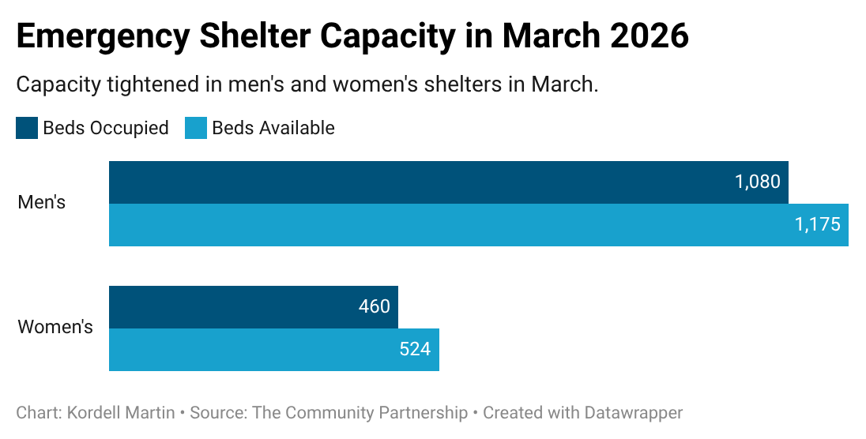
Shelter capacity is monitored nightly to determine if additional beds are needed to meet demand, according to the DHS spokesperson. Capacity demands can vary at different points of the year, as some shelters are open when weather poses a significant risk to the health of those experiencing homelessness, like hypothermia season, which DHS dates from Nov. 1 to April 15.
Some prefer living outside to staying in shelters, but in other cases, if people seeking shelter are turned away, they may be forced to either sleep outside or travel to find facilities outside of their current ward. The DHS spokesperson said people experiencing homelessness can call the District’s Shelter Hotline for free transportation to shelters from anywhere in the city if they can’t find a facility near them.
One resident who lived outside of an abandoned building at 2230 Adams Place NE told Street Sense they had been in several encampments in the area for two years and had been living outside for five. The individual said they plan to “stay out here” until they receive a referral for a housing voucher, as they were not willing to stay in a low-barrier shelter. The resident described the living conditions of outside encampments as “rough.”
Mayor Bowser presented her proposed Fiscal Year 2027 budget on April 10. The budget, which totals $1.1 billion less than the previous year, sees significant cuts to homeless service programs, including housing vouchers and rapid rehousing.
DHS is facing a 7.5% decrease in its overall budget. According to DHS Director Rachel Pierre in a partnered briefing with the Interagency Council on Homelessness and Fair Budget Coalition D.C., the proposal provides opportunities for advancing shelter system reforms despite the difficult financial period.
The proposed budget allows for emergency shelters to support 405 families daily, compared to the 440 families currently supported by emergency shelters. In contrast, services like Permanent Supportive Housing (PSH) expect to assist nearly 3,000 families, alongside 4,734 individuals.
The budget proposal funds no new housing vouchers, leaving nearly 40,000 individuals in need of housing on the housing voucher waitlist.
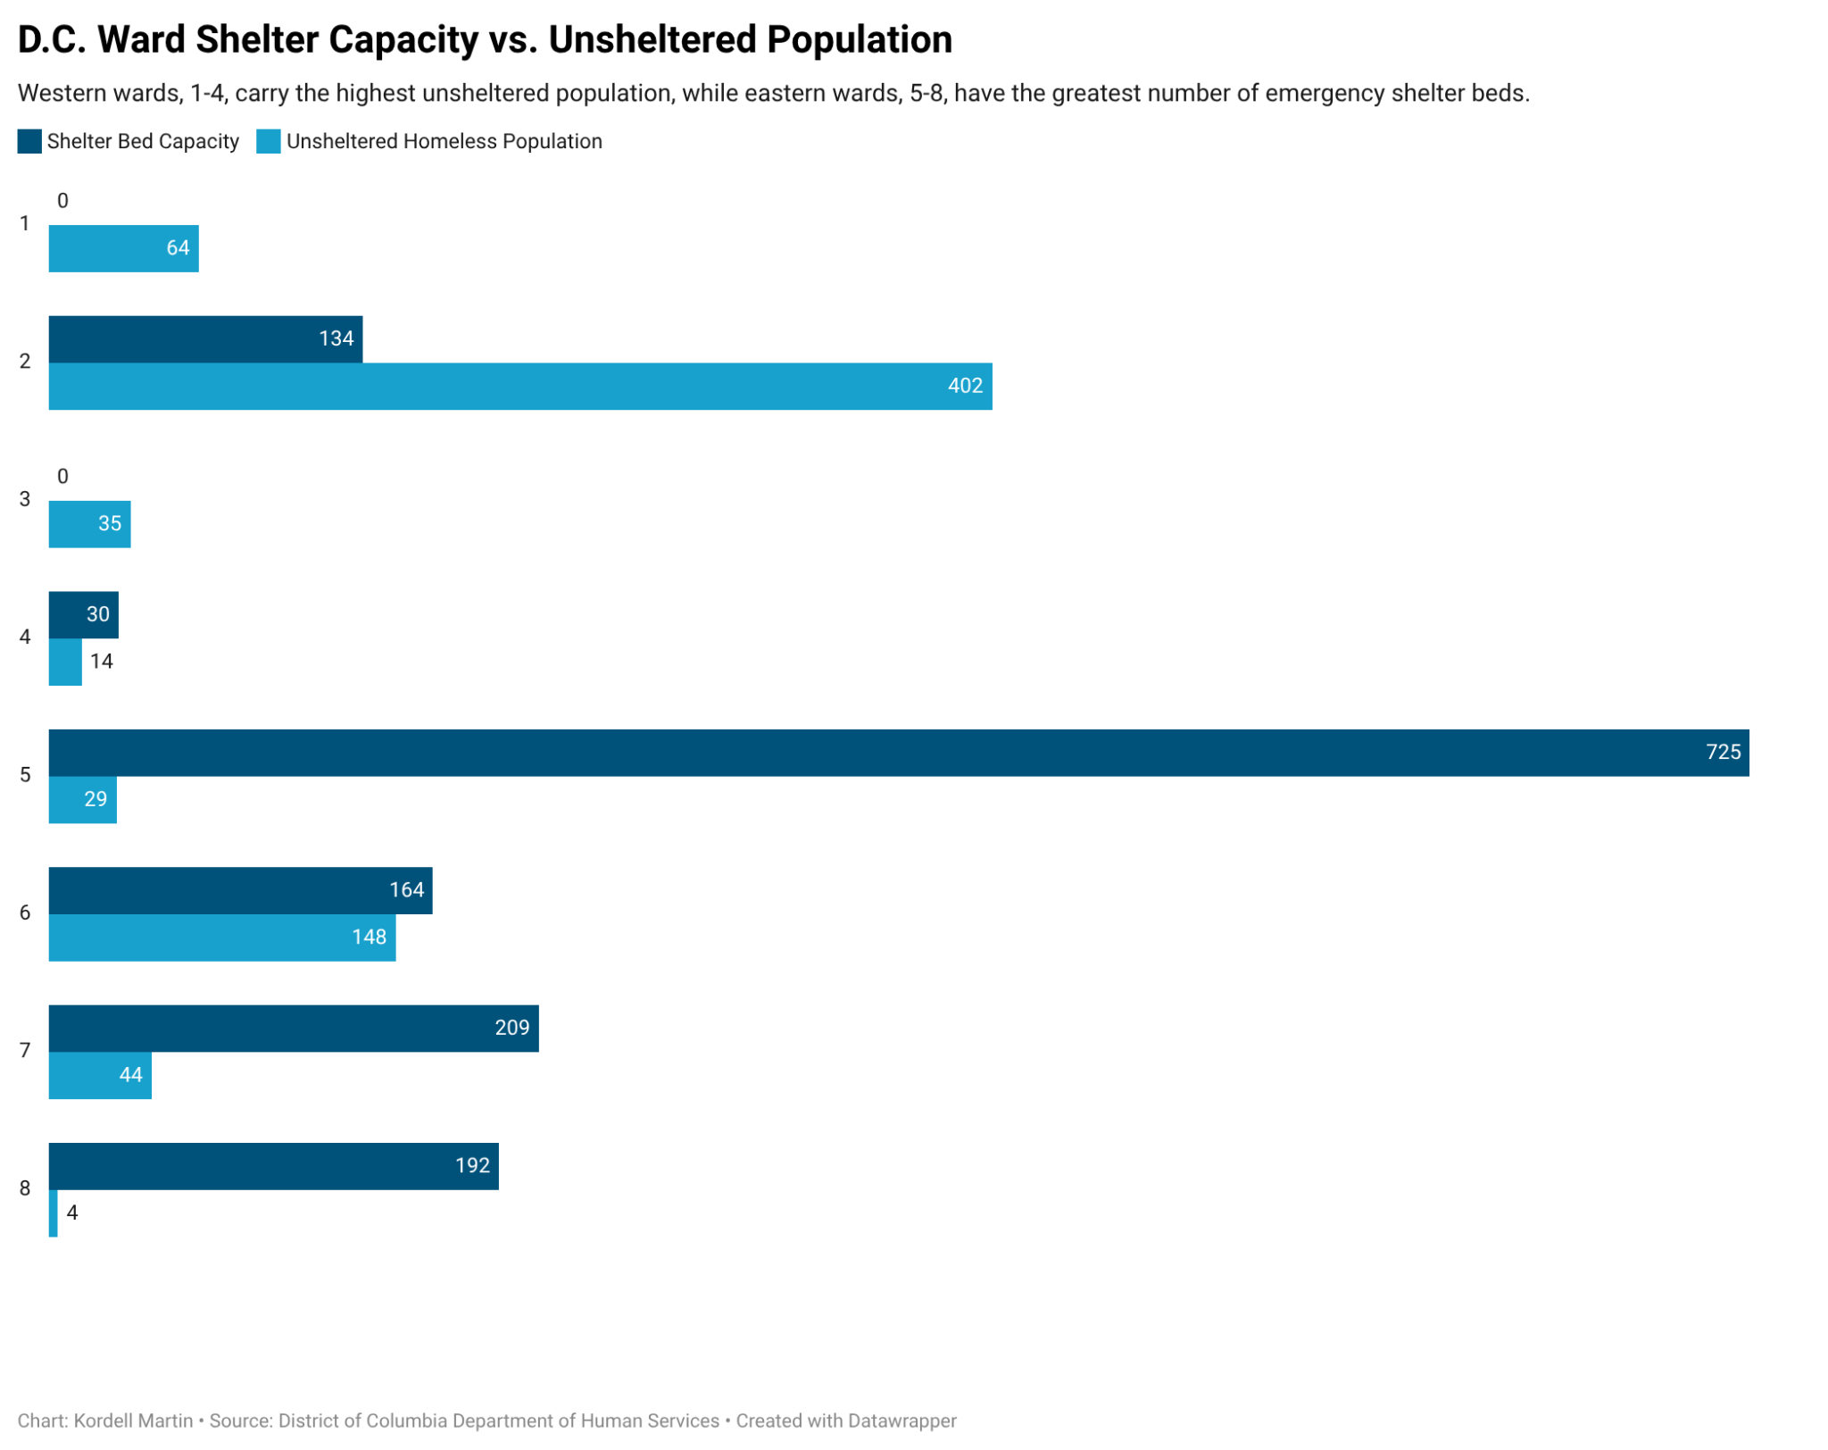
Ward 2’s only low-barrier shelter, The Patricia Hardy Place for Women, has less than half the beds needed to accommodate the ward’s total unsheltered population. Since the facility is dedicated to only sheltering women, men experiencing homelessness in the ward may have to travel for shelter or stay in outside encampments.
Adult men make up about 70% of unaccompanied individuals experiencing homelessness in the District, according to the 2025 PIT Count report by the Metropolitan Washington COG. There are currently no emergency shelter sites in Ward 2 that serve men experiencing homelessness.
Ward 2 Councilmember Brooke Pinto did not address the lack of low-barrier shelters in the ward, leaving it uncertain if the Patricia Handy Place for Women will continue to operate as the ward’s lone emergency shelter.
Pinto said she has instead shifted her priority to expanding capacity in Ward 2’s non-congregate shelter, The Ashton. Since last year, Pinto has been pushed by advocate groups and advisory neighborhood commissioners to increase the shelter’s capacity, which would expand access to stable housing programs for unsheltered individuals in the area.
“Helping move neighbors into stable indoor housing has always been a priority for me. Working with the community and the mayor, we opened The Aston in Ward 2, where residents have access to full-time case management and meals, and work to transition into a more permanent housing option.”
Since its opening in 2024 as D.C.’s first high-barrier shelter, programming requires individual referral for access to services that secure permanent housing while living in semi-private and private bedrooms. Referrals for the high barrier shelters are made through the Coordinated Assessment & Housing Placement (CAHP).
During some encampment closures in April, members of Miriam’s Kitchen and the Washington Legal Clinic for the Homeless told Street Sense they insisted that homeless residents start the referral process into non-congregate shelters to improve their chances of gaining stable housing.
Brittany Ruffin, senior counsel at the Washington Legal Clinic for the Homeless, said that she agreed with the District prioritizing non-congregate shelters, according to previous reporting by The Washington Post. Ruffin pointed to previous examples where D.C. tried to maintain capacity in low-barrier, congregate shelters by moving families into public areas like community gymnasiums instead of leaving them outside.
In response to previous budget cuts to homelessness services, Ruffin urged the District to better practice its housing programs in a 2025 statement for the Washington Legal Clinic for the Homeless.
“Funding essential programs is critical, but D.C. must also ensure that funds are being used to serve communities well,” Ruffin said. Residents must be respected and protected, the provision of human services and housing must be high-quality, and programs must be available, accessible, and legally compliant.”

GOOGLE SHEETS: Shelter Capacity and PIT Count by ward - Google Sheets

